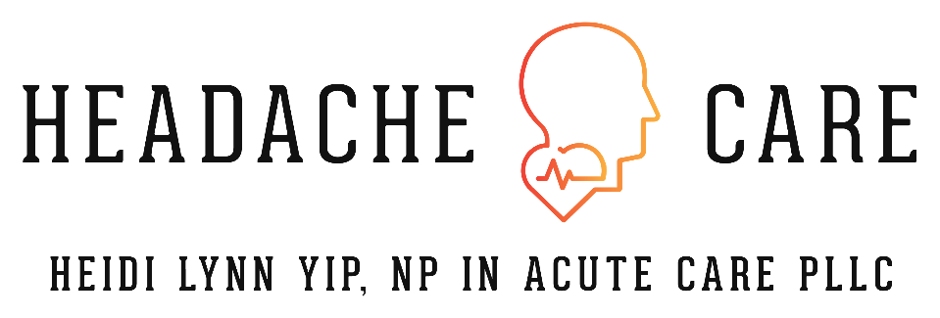

Welcome Letter

Welcome to Heidi Lynn Yip, NP in Acute Care PLLC! We are so glad you have entrusted us to join your healthcare team. We look forward to meeting you at your consultation.

Please note that Heidi Lynn Yip, NP in Acute Care PLLC is a private medical practice and therefore we are not able to access any of your medical records without signed consent. As well, we do not participate with any financial assistance programs that the large health systems are able to offer.

Please take time to read through our office policies to familiarize yourself with what is to be expected of us and our patients. You will be asked to sign that you have read and understand all policies.

Please bring with you the following information at each office visit:
Photo Identification
Insurance Card
Method of Payment
Medication List with Names, Dosages, and Instructions (prescription, OTC, supplements)
Updated Medical History and Allergies

Again thank you so much and we will see you soon!

